**Image Recognition with IBM Cloud Visual Recognition**

**Phase 4 Submission Document**

**Development part 2**

**Project Title : Facial-emotion-recognition-model**

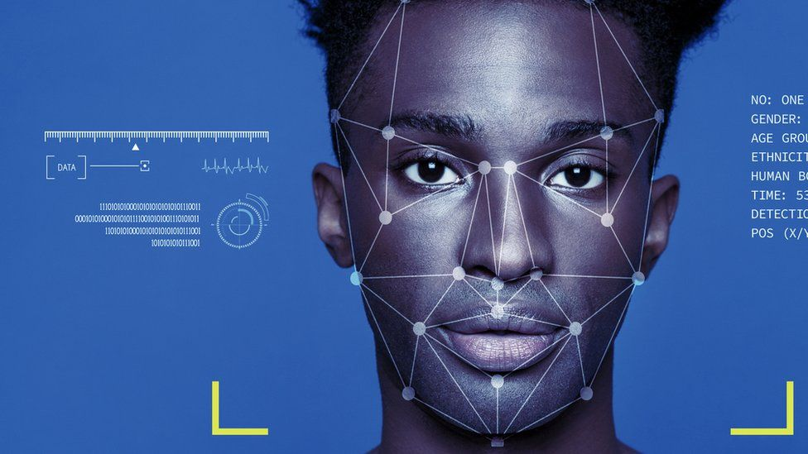

**Introduction:**

IBM Watson studio is a very cool interface that lets create models and train them making able to perform visual recognition with a decent percentage of accuracy, we going to show how to use IBM Watson Studio to train a model that detects if a picture belongs to a certain criteria.

**Data Sources and Setup**

Before running the scripts for the image recognition project, it's crucial to set up the required datasets. This document provides an overview of the datasets used in our project and how to obtain them.

**Datasets:**

**CK+ (Cohn-Kanade Extended+):**

**Source:**

<https://www.kaggle.com/datasets/shawon10/ckplus>

Description: The CK+ dataset contains facial expressions captured in lab-controlled environments. It includes seven different emotion labels, making it suitable for training and testing emotion recognition models.

**FER-13 (Facial Expression Recognition 2013):**

**Sources:**

<https://www.kaggle.com/datasets/msambare/fer2013>

<https://www.kaggle.com/datasets/deadskull7/fer2013>

Description: The FER-13 dataset is a collection of images representing facial expressions. It contains various emotional states, enabling comprehensive training and testing for emotion recognition.

**FERPlus:**

Source:

<https://github.com/microsoft/FERPlus>

Description: FERPlus is an extension of the FER-13 dataset, providing a more refined annotation of emotions. It includes additional labels, offering improved granularity in emotion recognition.

**Data Setup:**

To run the image recognition scripts successfully, follow these steps:

* Download the CK+, FER-13, and FERPlus datasets from their respective sources.
* Organize the dataset files according to your project's directory structure.

**Data Preprocessing for Emotion Recognition Model**

* In the field of emotion recognition using deep learning, data preprocessing plays a pivotal role in shaping the effectiveness of the models.
* This document outlines essential data preprocessing steps to prepare the FERPlus dataset for training emotion recognition models.

**Emotion-Based Sorting:**

Images are further sorted into subfolders within the training and test sets based on the dominant emotion category they represent.

**Execution:**

The Python script provided automates the data preprocessing steps mentioned above. It ensures that the FERPlus dataset aligns with the FER-2013 dataset's structure and emotion categories.

**Steps to train the model:**

* From the Projects page in Watson Studio, add a new project.
* When prompted, select the Visual Recognition project type.
* If you have no instances of the Visual Recognition service, a new instance will be created. If you have existing instances, you have a choice:
* Click the Existing option to associate an existing instance with the project
* Click the New option to create another new instance

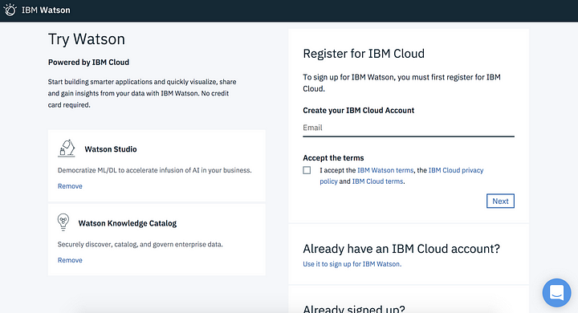

Next, let’s create a custom model*.*You can create IBM Watson Visual Recognition custom models, trained with your own images, to suit your specific visual recognition needs. This topic describes how to use the Visual Recognition model builder in IBM Watson Studio to create a custom model.

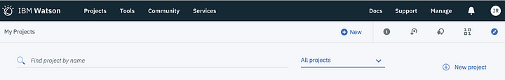

**Follow this steps…**

* [Prepare your images](https://datascience.ibm.com/docs/content/analyze-data/visual-recognition-prepare.html?linkInPage=true)
* Collect a minimum of 10 images for each class in ZIP (.zip) files, and then upload them to your project.
* In the Visual Recognition model builder, define your classes and add images.

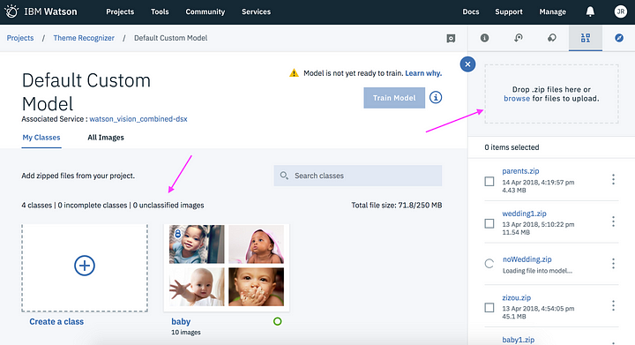

* Once the Zip files with sets of images, you drop them on the right top box, each set of them will create a class but what is a class? well, each class represents a set of images with certain criteria, let’s say we want a model that detects animals, you may want to add a zip file for a class of birds, a zip file for a class of reptiles, etc, you get the picture right?
* One cool thing about training a model is that you can add a zip file of images and set them to negative, let’s continue with the example of the animals detector, well we want to add a bunch of images of people on the negative class.
* Once our classes have images our model is ready to be trained! tap the “Train Model” button and wait, it may take some time to be ready, from my experience around 10 to 20 minutes, I assume that may depend on the number of files uploaded.
* Go to IBM Watson studio and download our model.

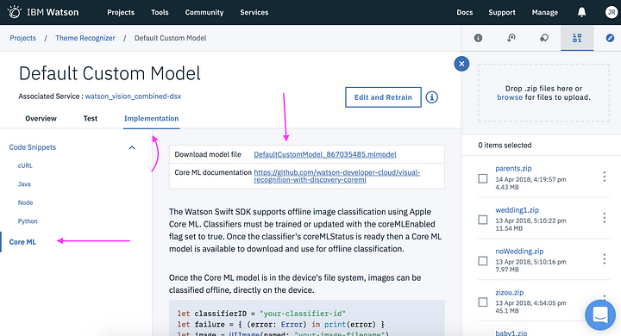

**Conclusion:**

In the second phase of our image recognition development, we train our model in ibm cloud Watson studio by the prepared dataset from different platforms and use the different emotions images of datasets to train the Watson studio model to recognize the facial emotions.

**Team members:**

MOHAMMED RAFFIYUTHEEN J

SANTHOSHKUMAR J

GOPIKRISHNAN A

SRINIVASAN K N